# Object Detection

A Synopsis Submitted

in Partial Fulfillment of the Requirements

for the Course of

# Minor Project - II

In

Third year – Sxith Semester of

**Bachelor of Technology**

specialization

In

# Business Analytics and Optimization

Under

**Bhupesh Kumar Dewangan**

By

# 500069030 R103218156 Sourabh Verma

# 500068489 R103218167 Vinay

# 500067581 R103218163 Tushar Goyal

# 500069419 R103218140 Shivam Sahu



DEPARTMENT OF INFORMATICS

SCHOOL OF COMPUTER SCIENCE

UNIVERSITY OF PETROLEUM AND ENERGY STUDIES, BIDHOLI, DEHRADUN, UTTRAKHAND, INDIA

# Jan , 2020

Synopsis

1. **Introduction**

Object detection is a well-known computer technology

connected with computer vision and image processing that

focuses on detecting objects or its instances of a certain class

(such as humans, flowers, animals) in digital images and

videos. Object detection from a complex background is a challenging

application in image processing. This is not a new technique but improvement in object detection is still required in order to achieve the targeted objective more efficiently and accurately.

Today, images and video are everywhere. Online photo sharing sites and social networks have them in the billions. The field of vision research[1,] has been dominated by machine learning and statistics. Using images and video to detect, classify, and track objects or events in order to ”understand” a real-world scene. Programming a computer and designing algorithms for understanding what is in these images is the field of computer vision.

Cancer is a major threat to mankind as the end consequences involved is primarily death. In the past century medical sciences were able to understood what cancer really is and how it can be cured. It involves abnormal cell growth that spreads at a very fast rate to all parts of the body. The most commonly diagnosed cancers are skin, Lung, pancreas and skin.

The main aim of studying and researching computer vision is

to simulate the behavior and manner of human eyes directly

by using a computer and later on develop a system that

reduces human efforts. Computer vision is such kind of

research field which tries to perceive and represents the 3D

information for world objects. Its main purpose is

reconstructing the visual aspects of 3D objects after analyzing

the 2D information extracted. Real life 3D objects are

represented by 2D images. It is one of the main technologies that enables the digital world to interact with the physical world. Computer vision algorithms detect facial features in images and compare them with databases of face profiles.

Image processing aims to transform an image into digital form and performs some process on it, to get an enhanced image or take some utilized information from it.

OpenCV is a library of programming functions mainly aimed at real-time computer vision.

**Motivation**

The motivation behind this project is to locate the beginning phase of lung cancer with high precision. In this project we will learn more about image processing and object detection Opencv. About 85% male and 75% females are suffering from lung cancer due to cigarette smoking. The general survival rate of people suffering from lung cancer is 63%. In spite of the fact that surgery, radiation treatment, and chemotherapy have been utilized as a part of the treatment of lung tumour, the five-year survival rate for all stages consolidated is just 14%. This has not changed in the previous three decades.

**Related work**

We will apply image processing and computer vision technologies to detect tumor in lung on the basis of previous work.

Let's say, Lung cancer is a disease of abnormal cells multiplying and growing into a tumor. The process of early detection of cancer plays an important role to prevent

cancer cells from multiplying and spreading. Previous researches have been conducted for analyzing

lung cancer such as using clustering method in microarray data, the detection of lung cancer with

general image processing techniques in CT scan data with good results and accuracy. In this study

we proposed and evaluated additional image segmentation methods in analyzing lung cancer using image

processing techniques.

A web application has been developed to demonstrate a proof of concept. The application requires a user to upload a CT Scan. The application then processes the ﬁle and displays the images to the user. The user then chooses which scan he or she wants to predict then the application pre-processes the CT Scan and infers the image to the predictive model. The output of the model is then displayed to the user. The user has the choice to view the images via a carousel or a gallery mod.

We also learnt about various methods and algorithms for Object Detection where the some key points were identified for every object using different algorithms.

**Methodology**

# 1. Applying machine learning algorithms like SVM , Decision tree by using image processing for lung cancer detection.

2. Creating an app for general use by the person for detecting Lung cancer.

3. using opencv to capture important parameters from image like Count of tumours , Size of tumours , Maximum size of tumours.

The main aim of studying and researching computer vision is

to simulate the behaviour and manner of human eyes directly

by using a computer and later on develop a system that

reduces human efforts. Computer vision is such kind of

research field which tries to perceive and represents the 3D

information for world objects. Its main purpose is

reconstructing the visual aspects of 3D objects after analysing

the 2D information extract

**Plan of work :**

We will use computer vision and image processing.

Output is the last stage in which result can be altered image or report that is based on image analysis. Image processing is a method to convert an image into digital form and perform some operations on it, in order to get an enhanced image or to extract some useful information from it.

The first stage starts with taking a collection of CT images (normal and abnormal) from the available Database from IMBA Home (VIA-ELCAP Public Access). The second stage applies several techniques of image enhancement, to get best level of quality and clearness. The third stage applies image segmentation algorithms which play an effective rule in image processing stages, and the fourth stage obtains the general features from enhanced segmented image which gives indicators of normality or abnormality of images.

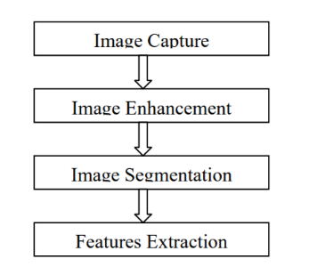

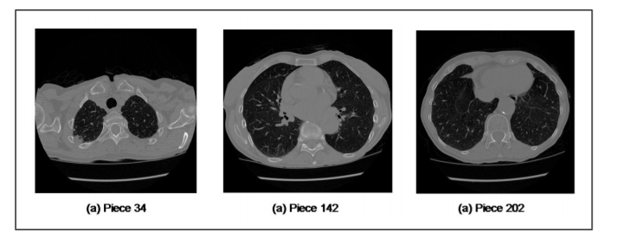

Image features Extraction stage is an important stage that uses algorithms and techniques to detect and isolate various desired portions or shapes (features) of a given image. To predict the probability of lung cancer presence, the following two methods are used: binarization and masking, both methods are based on facts that strongly related to lung anatomy and information of lung CT imaging.

The aim of this research is to detect features for accurate images comparison as pixels percentage and mask-labelling.

The main aim is to detect the objects and the output objects are detected from the real scene.

**References**

[1] Bariqi Abdillah, Alhadi Bustamam, and Devvi Sarwinda , “Image processing based detection of lung cancer on CT scan images”, Faculty of Mathematics and Science, Universitas Indonesia, Depok, Indonesia, The Asian Mathematical Conference 2016 (AMC 2016).

[2] Mokhled S. AL-TARAWNEH , “Lung Cancer Detection Using Image Processing Techniques”, Mutah University, B.O.Box (7), Mutah 61710, Jordan , ISSN 1583-1078 .

[3] Souhail Guennouni, Ali Ahaitouf, and Anass Mansouri, “Multiple Object Detection using OpenCV on an Embedded Platform”, Sidi Mohammed Ben Abdellah University School of Science and Technology Signals Systems and Components Laboratory B.P. 2202, 30000 Fez, Morocco.

[4] Sander Soo, “Object detection using Haar-cascade Classifier”, Institute of Computer Science, University of Tartu.

[5] Fares Jalled, “Object Detection Using Image Processing”, Moscow Institute of Physics & Technology, Department of Radio Engineering & Cybernetics Ilia Voronkov, Moscow Institute of Physics & Technology, Department of Radio Engineering & Cybernetics.

[6] Chandan G, Ayush Jain, Harsh Jain, Mohana, “Real Time Object Detection and Tracking Using Deep Learning and OpenCV”, Proceedings of the International Conference on Inventive Research in Computing Applications (ICIRCA 2018) IEEE Xplore Compliant Part Number:CFP18N67-ART; ISBN:978-1-5386-2456-2.